Conception association Farha

*Dictionnaire de données:*

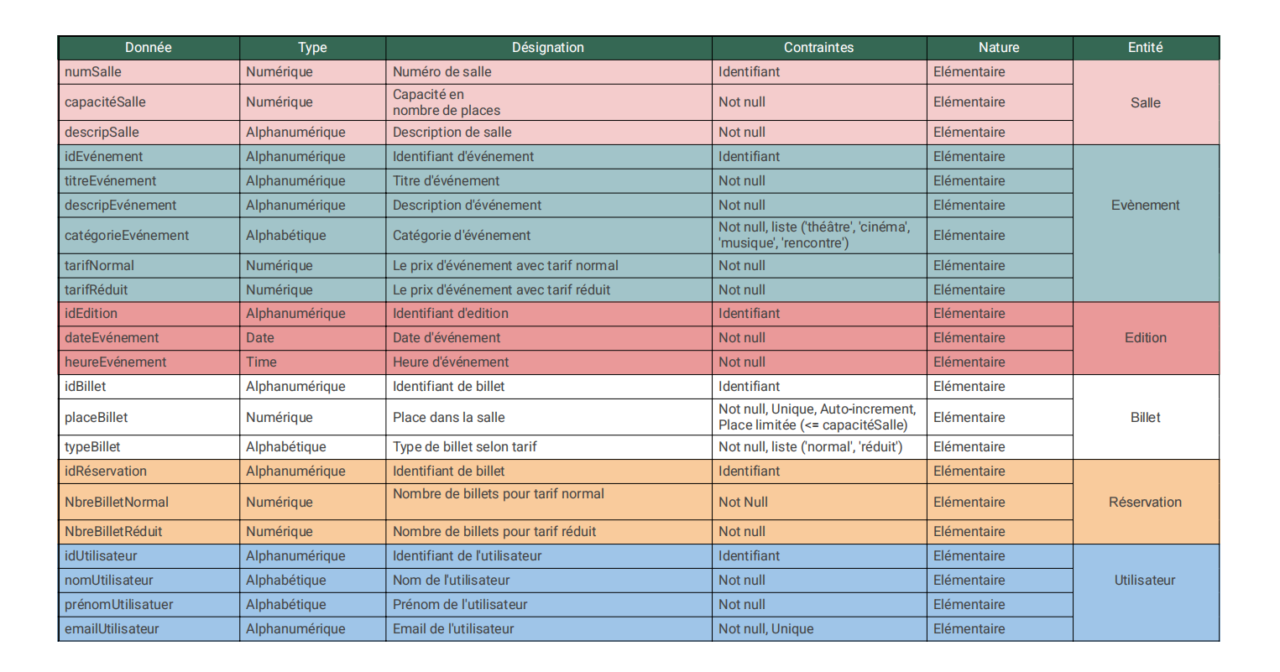

*Modèle Conceptuel de Données:*

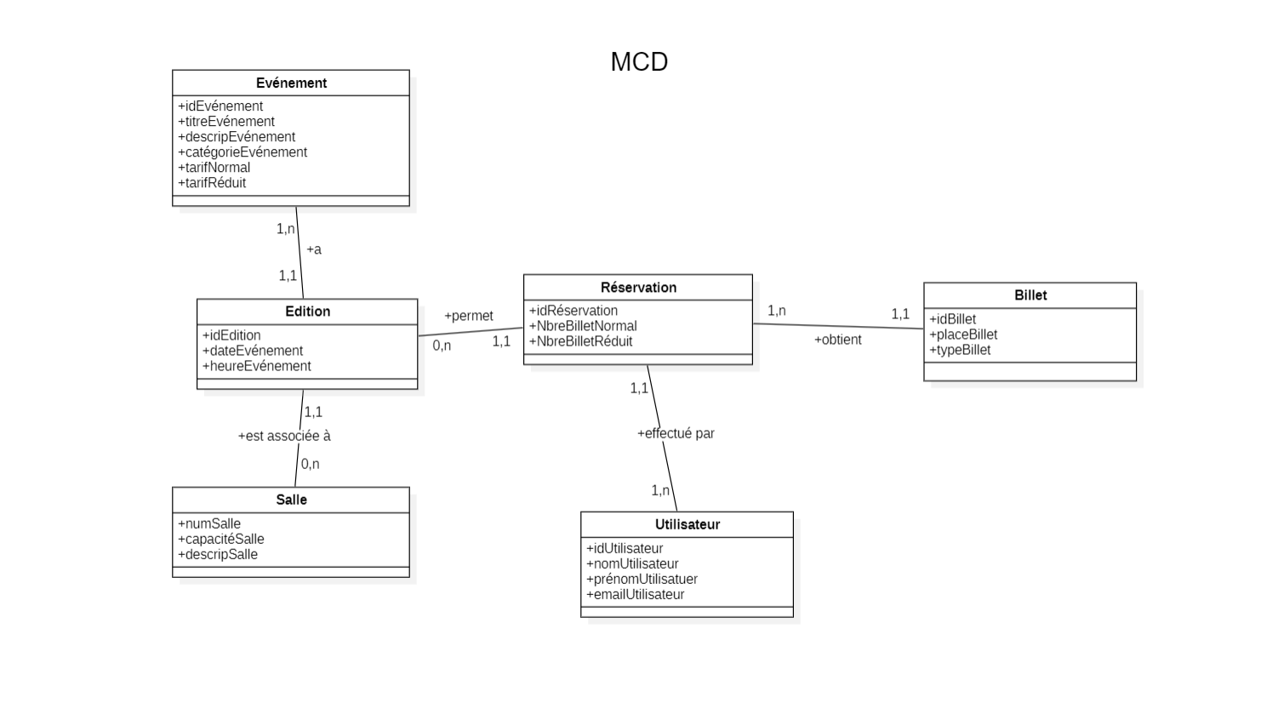

*Modèle Logique de Données:*

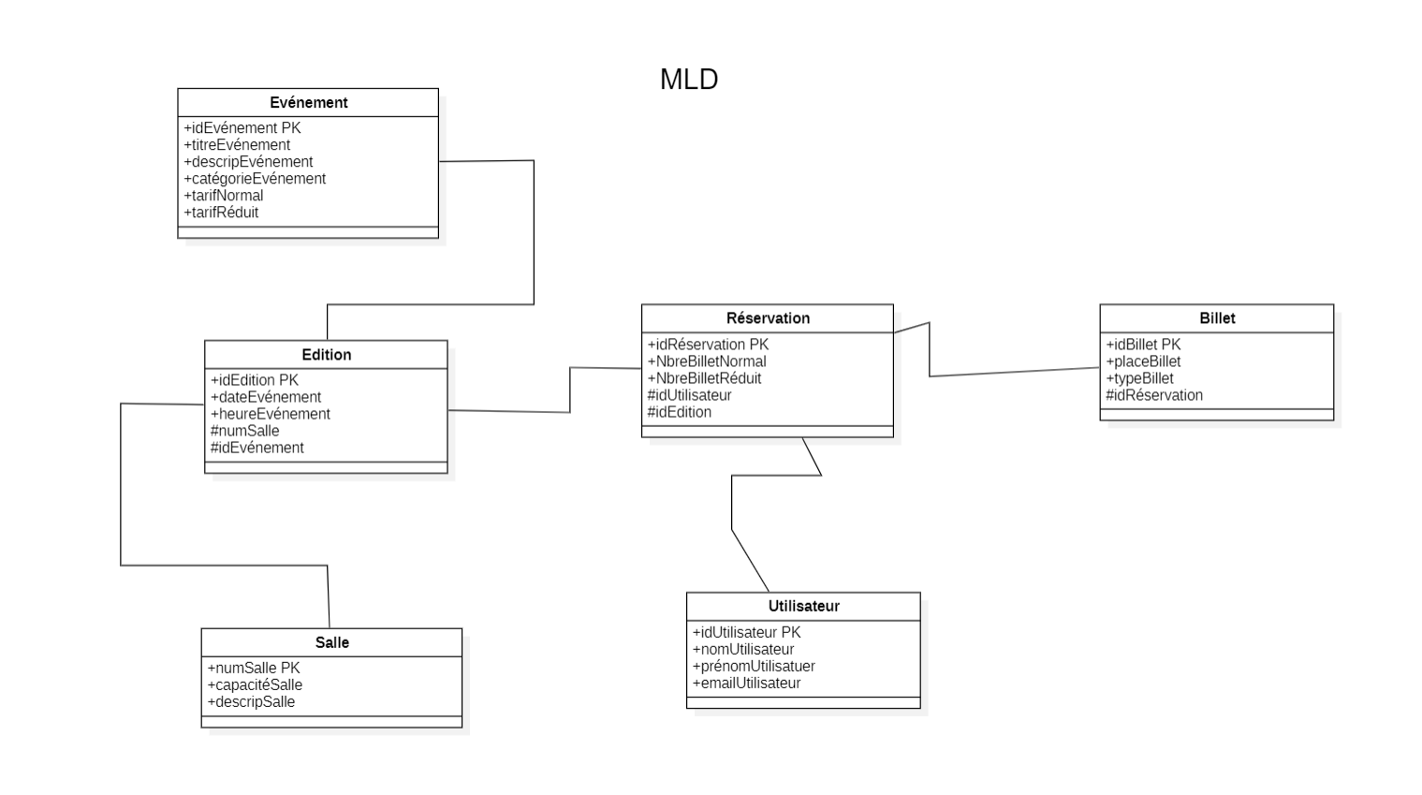

*Script de la base de données:*

-- Création de la base de données

[CREATE](http://localhost/phpmyadmin/url.php?url=https://dev.mysql.com/doc/refman/8.0/en/create-database.html" \t "http://localhost/phpmyadmin/index.php?route=/server/mysql_doc) [DATABASE](http://localhost/phpmyadmin/url.php?url=https://dev.mysql.com/doc/refman/8.0/en/create-database.html" \t "http://localhost/phpmyadmin/index.php?route=/server/mysql_doc) Farha;

USE Farha;

-- Table Salle

[CREATE](http://localhost/phpmyadmin/url.php?url=https://dev.mysql.com/doc/refman/8.0/en/create-table.html" \t "http://localhost/phpmyadmin/index.php?route=/database/mysql_doc) [TABLE](http://localhost/phpmyadmin/url.php?url=https://dev.mysql.com/doc/refman/8.0/en/create-table.html" \t "http://localhost/phpmyadmin/index.php?route=/database/mysql_doc) Salle (

numSalle INT PRIMARY KEY,

capaciteSalle INT [NOT](http://localhost/phpmyadmin/url.php?url=https://dev.mysql.com/doc/refman/8.0/en/logical-operators.html%23operator_not" \t "http://localhost/phpmyadmin/index.php?route=/database/mysql_doc) NULL,

descripSalle VARCHAR(255) [NOT](http://localhost/phpmyadmin/url.php?url=https://dev.mysql.com/doc/refman/8.0/en/logical-operators.html%23operator_not" \t "http://localhost/phpmyadmin/index.php?route=/database/mysql_doc) NULL

);

-- Table Evenement

[CREATE](http://localhost/phpmyadmin/url.php?url=https://dev.mysql.com/doc/refman/8.0/en/create-table.html" \t "http://localhost/phpmyadmin/index.php?route=/database/mysql_doc) [TABLE](http://localhost/phpmyadmin/url.php?url=https://dev.mysql.com/doc/refman/8.0/en/create-table.html" \t "http://localhost/phpmyadmin/index.php?route=/database/mysql_doc) Evenement (

idEvenement VARCHAR(30) PRIMARY KEY,

titreEvenement VARCHAR(100) [NOT](http://localhost/phpmyadmin/url.php?url=https://dev.mysql.com/doc/refman/8.0/en/logical-operators.html%23operator_not" \t "http://localhost/phpmyadmin/index.php?route=/database/mysql_doc) NULL,

descripEvenement VARCHAR(255) [NOT](http://localhost/phpmyadmin/url.php?url=https://dev.mysql.com/doc/refman/8.0/en/logical-operators.html%23operator_not" \t "http://localhost/phpmyadmin/index.php?route=/database/mysql_doc) NULL,

categorieEvenement VARCHAR(50) [NOT](http://localhost/phpmyadmin/url.php?url=https://dev.mysql.com/doc/refman/8.0/en/logical-operators.html%23operator_not" \t "http://localhost/phpmyadmin/index.php?route=/database/mysql_doc) NULL,

 tarifNormal DECIMAL(8,2) [NOT](http://localhost/phpmyadmin/url.php?url=https://dev.mysql.com/doc/refman/8.0/en/logical-operators.html%23operator_not" \t "http://localhost/phpmyadmin/index.php?route=/database/mysql_doc) NULL, tarifReduit DECIMAL(8,2) [NOT](http://localhost/phpmyadmin/url.php?url=https://dev.mysql.com/doc/refman/8.0/en/logical-operators.html%23operator_not" \t "http://localhost/phpmyadmin/index.php?route=/database/mysql_doc) NULL,

CONSTRAINT checkcategory CHECK (categorieEvenement [IN](http://localhost/phpmyadmin/url.php?url=https://dev.mysql.com/doc/refman/8.0/en/comparison-operators.html%23function_in" \t "http://localhost/phpmyadmin/index.php?route=/database/mysql_doc) ('théâtre', 'cinéma', 'musique', 'rencontre'))

);

-- Table Edition

[CREATE](http://localhost/phpmyadmin/url.php?url=https://dev.mysql.com/doc/refman/8.0/en/create-table.html" \t "http://localhost/phpmyadmin/index.php?route=/database/mysql_doc) [TABLE](http://localhost/phpmyadmin/url.php?url=https://dev.mysql.com/doc/refman/8.0/en/create-table.html" \t "http://localhost/phpmyadmin/index.php?route=/database/mysql_doc) Edition (

idEdition VARCHAR(30) PRIMARY KEY, numSalle INT,

idEvenement VARCHAR(30), dateEvenement DATE [NOT](http://localhost/phpmyadmin/url.php?url=https://dev.mysql.com/doc/refman/8.0/en/logical-operators.html%23operator_not" \t "http://localhost/phpmyadmin/index.php?route=/database/mysql_doc) NULL,

heureEvenement TIME [NOT](http://localhost/phpmyadmin/url.php?url=https://dev.mysql.com/doc/refman/8.0/en/logical-operators.html%23operator_not" \t "http://localhost/phpmyadmin/index.php?route=/database/mysql_doc) NULL,

FOREIGN KEY (numSalle) REFERENCES Salle(numSalle) ON [DELETE](http://localhost/phpmyadmin/url.php?url=https://dev.mysql.com/doc/refman/8.0/en/delete.html" \t "http://localhost/phpmyadmin/index.php?route=/database/mysql_doc) CASCADE ON [UPDATE](http://localhost/phpmyadmin/url.php?url=https://dev.mysql.com/doc/refman/8.0/en/update.html" \t "http://localhost/phpmyadmin/index.php?route=/database/mysql_doc) CASCADE,

FOREIGN KEY (idEvenement) REFERENCES Evenement(idEvenement) ON [DELETE](http://localhost/phpmyadmin/url.php?url=https://dev.mysql.com/doc/refman/8.0/en/delete.html" \t "http://localhost/phpmyadmin/index.php?route=/database/mysql_doc) CASCADE ON [UPDATE](http://localhost/phpmyadmin/url.php?url=https://dev.mysql.com/doc/refman/8.0/en/update.html" \t "http://localhost/phpmyadmin/index.php?route=/database/mysql_doc) CASCADE

);

-- Table Utilisateur

[CREATE](http://localhost/phpmyadmin/url.php?url=https://dev.mysql.com/doc/refman/8.0/en/create-table.html" \t "http://localhost/phpmyadmin/index.php?route=/database/mysql_doc) [TABLE](http://localhost/phpmyadmin/url.php?url=https://dev.mysql.com/doc/refman/8.0/en/create-table.html" \t "http://localhost/phpmyadmin/index.php?route=/database/mysql_doc) Utilisateur (

idUtilisateur VARCHAR(30) PRIMARY KEY,

nomUtilisateur VARCHAR(30) [NOT](http://localhost/phpmyadmin/url.php?url=https://dev.mysql.com/doc/refman/8.0/en/logical-operators.html%23operator_not" \t "http://localhost/phpmyadmin/index.php?route=/database/mysql_doc) NULL, prenomUtilisateur VARCHAR(300) [NOT](http://localhost/phpmyadmin/url.php?url=https://dev.mysql.com/doc/refman/8.0/en/logical-operators.html%23operator_not" \t "http://localhost/phpmyadmin/index.php?route=/database/mysql_doc) NULL,

emailUtilisateur VARCHAR(200) UNIQUE [NOT](http://localhost/phpmyadmin/url.php?url=https://dev.mysql.com/doc/refman/8.0/en/logical-operators.html%23operator_not" \t "http://localhost/phpmyadmin/index.php?route=/database/mysql_doc) NULL

);

-- Table Reservation

[CREATE](http://localhost/phpmyadmin/url.php?url=https://dev.mysql.com/doc/refman/8.0/en/create-table.html" \t "http://localhost/phpmyadmin/index.php?route=/database/mysql_doc) [TABLE](http://localhost/phpmyadmin/url.php?url=https://dev.mysql.com/doc/refman/8.0/en/create-table.html" \t "http://localhost/phpmyadmin/index.php?route=/database/mysql_doc) Reservation (

idReservation VARCHAR(30) PRIMARY KEY,

NbreBilletNormal INT [NOT](http://localhost/phpmyadmin/url.php?url=https://dev.mysql.com/doc/refman/8.0/en/logical-operators.html%23operator_not" \t "http://localhost/phpmyadmin/index.php?route=/database/mysql_doc) NULL,

NbreBilletReduit INT [NOT](http://localhost/phpmyadmin/url.php?url=https://dev.mysql.com/doc/refman/8.0/en/logical-operators.html%23operator_not" \t "http://localhost/phpmyadmin/index.php?route=/database/mysql_doc) NULL,

idUtilisateur VARCHAR(30) [NOT](http://localhost/phpmyadmin/url.php?url=https://dev.mysql.com/doc/refman/8.0/en/logical-operators.html%23operator_not" \t "http://localhost/phpmyadmin/index.php?route=/database/mysql_doc) NULL, idEdition VARCHAR(30) [NOT](http://localhost/phpmyadmin/url.php?url=https://dev.mysql.com/doc/refman/8.0/en/logical-operators.html%23operator_not" \t "http://localhost/phpmyadmin/index.php?route=/database/mysql_doc) NULL,

FOREIGN KEY (idUtilisateur) REFERENCES Utilisateur(idUtilisateur) ON [DELETE](http://localhost/phpmyadmin/url.php?url=https://dev.mysql.com/doc/refman/8.0/en/delete.html" \t "http://localhost/phpmyadmin/index.php?route=/database/mysql_doc) CASCADE ON [UPDATE](http://localhost/phpmyadmin/url.php?url=https://dev.mysql.com/doc/refman/8.0/en/update.html" \t "http://localhost/phpmyadmin/index.php?route=/database/mysql_doc) CASCADE,

FOREIGN KEY (idEdition) REFERENCES Edition(idEdition) ON [DELETE](http://localhost/phpmyadmin/url.php?url=https://dev.mysql.com/doc/refman/8.0/en/delete.html" \t "http://localhost/phpmyadmin/index.php?route=/database/mysql_doc) CASCADE ON [UPDATE](http://localhost/phpmyadmin/url.php?url=https://dev.mysql.com/doc/refman/8.0/en/update.html" \t "http://localhost/phpmyadmin/index.php?route=/database/mysql_doc) CASCADE

);

-- Table Billet

[CREATE](http://localhost/phpmyadmin/url.php?url=https://dev.mysql.com/doc/refman/8.0/en/create-table.html" \t "http://localhost/phpmyadmin/index.php?route=/database/mysql_doc) [TABLE](http://localhost/phpmyadmin/url.php?url=https://dev.mysql.com/doc/refman/8.0/en/create-table.html" \t "http://localhost/phpmyadmin/index.php?route=/database/mysql_doc) Billet (

idBillet VARCHAR(30) PRIMARY KEY,

placeBillet INT UNIQUE AUTO_INCREMENT [NOT](http://localhost/phpmyadmin/url.php?url=https://dev.mysql.com/doc/refman/8.0/en/logical-operators.html%23operator_not" \t "http://localhost/phpmyadmin/index.php?route=/database/mysql_doc) NULL,

typeBillet VARCHAR(50) [NOT](http://localhost/phpmyadmin/url.php?url=https://dev.mysql.com/doc/refman/8.0/en/logical-operators.html%23operator_not" \t "http://localhost/phpmyadmin/index.php?route=/database/mysql_doc) NULL CHECK (typeBillet [IN](http://localhost/phpmyadmin/url.php?url=https://dev.mysql.com/doc/refman/8.0/en/comparison-operators.html%23function_in" \t "http://localhost/phpmyadmin/index.php?route=/database/mysql_doc) ('normal', 'réduit')),

idReservation VARCHAR(30) [NOT](http://localhost/phpmyadmin/url.php?url=https://dev.mysql.com/doc/refman/8.0/en/logical-operators.html%23operator_not" \t "http://localhost/phpmyadmin/index.php?route=/database/mysql_doc) NULL,

FOREIGN KEY (idReservation) REFERENCES Reservation(idReservation) ON [DELETE](http://localhost/phpmyadmin/url.php?url=https://dev.mysql.com/doc/refman/8.0/en/delete.html" \t "http://localhost/phpmyadmin/index.php?route=/database/mysql_doc) CASCADE ON [UPDATE](http://localhost/phpmyadmin/url.php?url=https://dev.mysql.com/doc/refman/8.0/en/update.html" \t "http://localhost/phpmyadmin/index.php?route=/database/mysql_doc) CASCADE

);